Waste and Garbage Recycling Vending Machine Project

Nowadays with the increasing quantity of waste generated and restricted lowland house for waste disposal, utilization is one in all the necessary approaches to manage the waste effectively. Concern over the atmosphere is being seen as a massive increase in recycling globally that has full-grown to be a vital a part of trendy civilization. Our garbage recycling system will help to segregate the recycled waste from the non-recyclable one and also provide monetary benefits to the person which in turn will boost the morale of people to recycle their waste. In this waste management vending machine, barcodes would be attached onto garbage bags; barcode will be having the information whether the garbage to be recycled is recyclable or is to be disposed. Such bags are then placed on the conveyor, on the way a barcode reader scans the bags and then determines the type of garbage and at the end of the conveyor a servo motor arrangement pushes the bags into their respective bins, the waste inside the non-recyclable bin is disposed and the weight of the recyclable waste is calculated and the user is provided with an amount proportional to the weight.
Block Diagram :
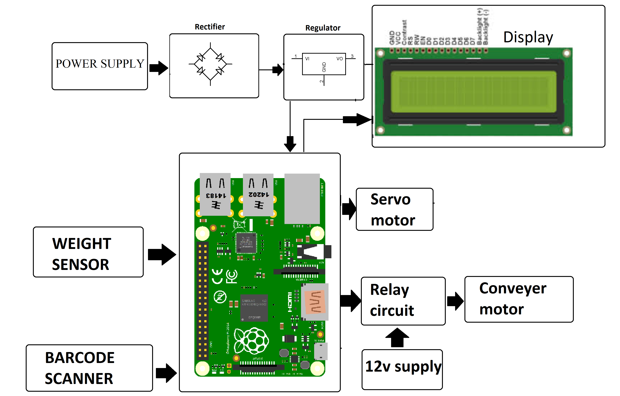

Hardware Specifications

- Raspberry Pi 3

- DC Motor

- Servo motor

- Barcode Scaneer

- Weight Sensor

- Relay

- IC

- IC Socket

- Buzzer-

- LCD’s

- Resistors

- Capacitors

- Transistors

- Cables & Connectors

- Diodes

- PCB

- LED’s

- Transformer/Adapter

- Push Button

- Switch

Software Requirements

- Python

- OS: Linux

